Mithril Horde I – All Quests Guide
This is a quest guide for every quest in The Quest - Mithril Horde I expansion by Zarista Games and Redshift Games.
For some quests, there are many ways of solving it. This is just my own way of doing it. It is not the only way! Following this guide will guarantee the green checkmark in the quest journal.
Some quests are easy and probably does not even need a guide. Some steps are too obvious. I still detailed it here for completion reasons. I recommend CTRL-F to find what you need here.
Rescue Cmonez, Bethlusaa’s Treasure, Lost Volume, Bring a Message
- Inside the lair, go to the “Inner Lair” Teleport. Tap all smokes and kill all mobs – you will get keys.
- At the very west end, you will find a note asking to mark that spot.
- 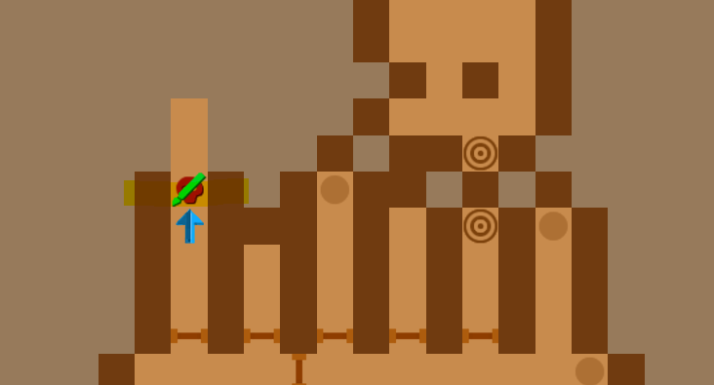
- The wall is a dead end… if you have not completed the Sharahazad quest. YOU MUST TURN IN THE QUEST/BLADE TO LORD YUZ. (I have not turned in mine, thinking I need the blade, so I wasted 2 hours searching how to proceed…)
- Once turned in, return to the spot, the wall will disappear.
- Proceed, there is a gate to the right. Cmonez is there. She will reject you, talk to her again. You will teleport back to the palace.
- Done - Bring a Message, tell her it is Sabrine. The quest will fail, but it is complete.
- Return to the marked spot and go forward. Teleport for the boss fight.
- Kill Bethlusaa, tap golden pillar in the southeast. Teleport to treasure room, loot all.
- Done – Return, this has the loot for the Bethlusaa’s Treasure and Lost Volume quest.
- Done – Return to Lord Yuz.
Lost Mines
- You need a map of the Heatrani mountains to start it. I simply brought mine from Phredd in Flitzgrobber’s Warehouse. Or you can just clear the Training Pit in the palace.
- Once started go to the Heatrani mountains. Near the Nine Dragon Wall.
- Break the odd colored wall.
- 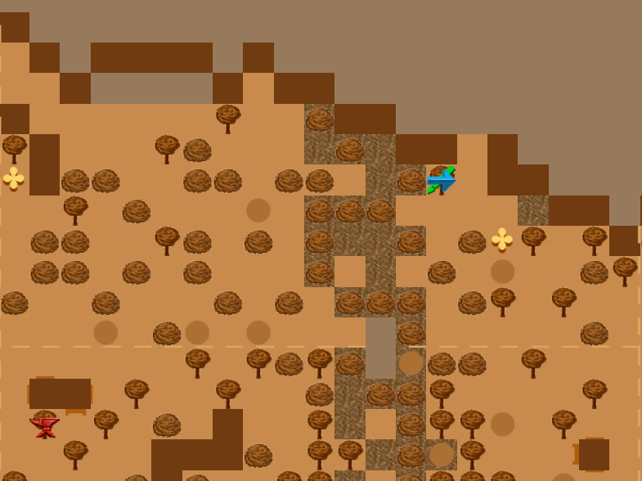
- Clear mine, it is small. You will get a map.
- Done – Return
Find the Remains
- Remains are in the red smoke directly 3 tiles south of the ghost.
- Done - Return
Bring a Token & Bring a locket
- Go to Kupaqi in the south most house on the left.
- New Quest: Bring a locket
- Done – Return to Durgis in Bethlusaa’s Lair
- Done – Return to the wife in Kupaqi
Lost Prophecy
- Go to Mt. Agong, in the center there is a spiral maze.
- Go down the hole.
- Go west of the entrance. See map.
- 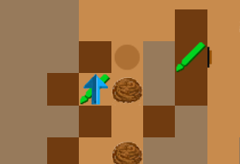
- Done – Return
Puzzle Book
- Go to Mt. Agong, in the center there is a spiral maze.
- Go down the hole.
- Go west of the entrance. See map of Lost Prophecy quest.
- Go south, then west. You will end up looping around to the north.
- Kan-Laon is at the north.
- 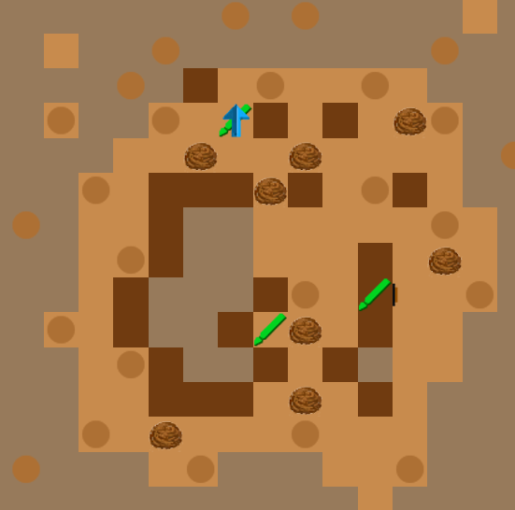
- You must take that path, or you will be teleported to start.
- Talk to him, you need around 100 persuasion.
- Done – Return
Dr. Aloy
- Go to Mt. Agong, in the center there is a spiral maze.
- Go down the hole.
- Dr. Aloy will be immediately north of the entrance
- Done – Return to Vaterguy in the Guild.
Four Storage Chests
- Second Floor Palace go upstairs on the east side – your room + storage.
- One of the doors is your room, other is storage. Enter storage.
- Clear everything. Tap all boarded windows – they have keys/chests.
- Chest #1 is in the north-east room, boarded window.
- You will be trapped one of the rooms – answer is 3690
- Chest #2 is in the trapped room on the floor. To escape - answer is north, south, east levers in that order. If it creaks, you did it right. Then tap a hidden button left of the gate (not the gates itself), close to the torch of the gate you entered. Looks like a stone brick.
- Chest #3 is in the pile of skulls, north-western tip of the map.
- Chest #4. Pressure plate room – Facing north… 1. Right side middle 2. Right side south 3. Left side south 4. Left side middle 5. Left side north 6. Right side north. Wall should open – south western tip of map. Chest is on shield on the wall.
- Done – Return to Lady Sithra
The Great Horde’s Garrisons
- Go to Heatrani Mountains east side. Most north-eastern tip in world map.
- There is a hole in the wall – enter.
- Clear everything – it is linear
- Done – Return to Lord Yuz
Mad Woman & Mechanical Heart
- Go to Home of the Mad Woman
- She is in the southern most house out of the 3.
- Pay her 10,000 gold and wait 1 minute (walk around few steps)
- Now she wants a heart, go to dwarf in Thatunka, the house directly south from her door.
- Go to the storage room.
- Walk 3 steps forward into the pentagram. You will teleport.
- Face east and move forward 2 steps. Then face north, 2 more steps.
- Missing number is 1.
- Tap the signs, 314159265 in this sequence.
- All walls are now open, ones with the signs on them.
- Clear the area, break blue colored walls. Pull every single lever.
- The hole in the south-east does not do anything.
- After pulling everything, the forcefield in the north-west should open.
- Loot the heart in the vase in that room.
- Done – Return to Mad Woman
- Done – Return to Lord Yuz
Measure the Wall
- Go to the Nine Dragon Wall
- Go all around the wall, leaving no tile undiscovered on mini map
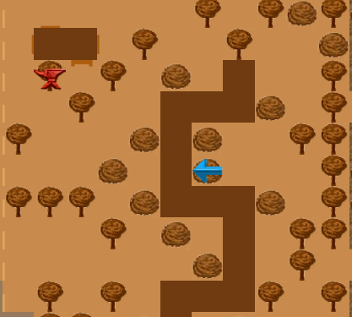
- Northern most alcove has two bushes. Behind is a hole, enter.
- Break the odd colored wall, revealing the tomb
- Clear everything, last coffin has the 6 Dragon Scrolls.
- Done – Return – Answer 30 blocks long.
Inspire Aria
- Kill Antu the Orang. It spawns immediately to the left of her.
- Done – Return
Mysterious Happenings & Rescue Faris
- Go north-east most of the Floating Market and tap the barrel
- It will talk, visit the door where the barrel is next to.
- New Quest: Rescue Faris
- Go to Pontiniakh and talk to the spell book salesman, Haridas in the center of town.
- Enter the door next to him. Tap blue colored wall. Loot chest on shelf.
- Done – Return to Nymph in the north-east
- Done – Return to Thorin in the south-west (wait a day to complete, just rest 6 times)
Open the Tomb
- Go to cemetery of the TikTiks, go down the stairs inside
- Clear area, tap each tomb
- Wall should open, revealing a portal, past it, a breakable wall
- Tap wall and tap the last tomb. You should get a Rock.
- Done – Return
- Note: The hole in the wall and the portal leads to bosses – not related to quest.
Beauty Elixir & Lady Miriame
- Go to cemetery of the TikTiks, talk to the Father in the north-west house
- He will teleport you to the Gates of Death, talk to lady Miriame
- Clear the place, then walk to pentagram in to north to leave
- Lady Miriame will be next to the Father, talk to her to finish her quest.
- Talk to father to receive the potion
- Done - return to Sabrine in the palace
- New quest – Bring a message (guide in another list, CRTL-F)
Cannibals of Kupaqi
- Clear everything inside the walls
- Go inside hole in the wall
- Clear everything underground
- One of the furthest east pillars has a crack, tap it
- This unlocks a hidden wall. Go north, break each odd colored wall
- Last Cannibal is hiding there.
- Done - Return
Dragon’s Egg & Sharahazad
- Simply buy it cheap from shops around Pontiniakh (random stock)
- Got mine in the tavern, I think?
- Or do it the intended hard way as detailed in the quest journal...
- Done – Return
- Go inside the flying machine, in center of the dwarf’s house
- Tap the skull, go to Floating Islands of Dryst
- Clear area and step into red portal
- Clear area #2 step into red portal again
- Clear final area and go north. The sword, Sharahazad is next to the coffin – loot it
- Done – Return to Lord Yuz
- Important Note! Do not turn in the quest if you have not rescued Cmonez yet. You need the sword.
Goddess of Love
- You need Love Point statues to proceed. (I had 9 when I did it).
- Nautical Charts quest (on shelves) and search Thousand Temples should give enough.
- Go to Thousand Temples in the western area -C shaped building
- Walk into rose bush adjacent to the water fountain
- Fall into hole, clear area
- Tap statue – that is Rati
- Done - Return
Mithril Darning Needle
- Go to palace, second floor
- Needle in blue pot in northeastern room
- Done - Return
Saviria’s Eyes
- Go to the northwestern most building
- Break odd color wall
- Tap on pile of skulls
- Done - Return
The Scavenger
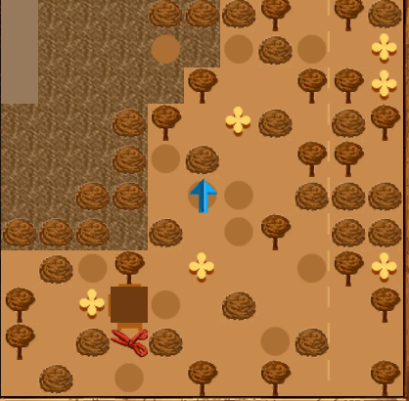
- Go to bay of Pontianak
- Must be nighttime
- Step on green grass with gray stone
- pirates come out, kill all 3
- Done - Return
Donation & Pass Mad Ivan’s Test
- Talk to Mad Ivan in the palace
- Answer is Blue Hat
- Done – candidates will be aggressive
- You will now be a high councilor.
- Go to the Grand Councilor
- You need a high appraisal skill (I had 70), pick the second option. Do not pick the first, or you will get teleported to the sewers.
- Done - Return
Nautical Charts
- Go to Thousand Temples in the southwestern tip of the map, there lies a path
- Talk to Orc then ride the boat
- Arrive at island, clear it, and enter the building
- Clear building, jumping portal to portal, then finally talk to Marinus
- Re-enter the first portal, arriving room has a purple pillar
- Tap it, it has the nautical maps
- Done – Return
Gather Ingredients (To cure Leptrosis)
- Go to Thousand Temples in the southwestern tip of the map, there lies a path
- You are now in Jingelly Island, tap 4 palm trees for leaves.
- Go to Heatrani Mountains – Tap rose looking bush.
- Done – Return to Liz in Map Maker’s Guild
Find the Sunken City
- Go to Bay of Pontiniakh – north-eastern tip.
- Enter hole in the water.
- Clear everything – one of the mobs should drop the spell book of Nemesis.
- Done – Return
Find the White Queen & Boris Spahsky’s Guide
- Go to Heatrani Mountains – east side
- Go to the building looking blocks, contrasted with the red blocks.
- Lock-pick the door – Very easy (I had lock-pick skill of 11).
- Enter – clear everything – linear dungeon
- Talk to the Chess Master – teleported.
- Again - Clear everything - talk to the Chess Master – teleported back.
- New Quest: Boris Spahsky’s Guide
- Go back to Lifehacker
- Go to Bethlusaa’s Lair (see Mad Woman quest to do that)
- In the lair there is a teleporter to “Central Teleporters”, then a teleporter to the “Dark Regions”.
- It is linear. In the end, there is a teleporter out. The book, Boris Spahsky’s Guide is next to it on the floor.
- Done - Return to the Chess Master.
- Done – Return to Lifehacker
Steal Back the Tusk & The Five Elixirs
- Go to cemetery of the TikTiks, near the Father in the north-west house
- Talk to Vin the Giant
- Bring 5 Pontiniakh Elixir Potions
- Buy 5 from any potion shop (random stock)
- Done – Return
- Reward – Horned Helm to enter Sekharet’s den in the Heatrani Mountains

- Go to Heatrani Mountains – west side
- Enter hole in the wall. You are in Sekharet’s den.
- Press down press plate on the end of the east wing.
- Tap the odd red candle on the end of the west wing.
- Gates should open. Clear everything.
- You should be in the final main room in the north.
- Go west and find a locked gate. Tap the pillar next to it, it has the key. Enter gate.
- Press hidden button in the north end of the corridor.
- Go all way east, meet Sekharet.
- Wear the Horned Helm and have a high stealth level (I had 90).
- Done – Return
Find Roland & Great Fur Cloak
- He is actually in Mt. Agong.
- Go as north, hugging the rock face. Approximately the middle of (the map) has a hole.
- Enter it. Roland will be right in front of you.
- New Quest: Great Fur Cloak
- Go north, open gate, clear everything. North pile of skulls has the cloak – tap it.
- Done – Return to Roland in the Guild.
- Done – Return to Chdo in the Guild
Copy a Map
- Get a piece of charcoal somewhere, the guild shelf or tavern…
- Go to Mt. Agong. Enter house on west side.
- Clear everything – cave is linear. Tap blue torch to proceed.
- Go down hole, clear everything. Enter another hole at the end. (The other hole/lair is extra, not quest related).
- You will be in Branching Caves – clear it – tap button in the north-east corner of map. (hidden brick in the wall). It should fill in the hole, allowing to proceed.
- At the end there is a blue odd colored wall.
- Done – Return
Celestial Rock Cave
- Go to Swamp of Menyerry and find a golden statue.
- Tap it and enter. Cave is linear. Clear it and you will receive a map.
- Done – Return
Explore the Old Temple
- Go to Kadariah Ruins on the west side, near the coast.
- Unlock and enter the gates, clear everything. Go down.
- Clear everything - one of the mobs drops a key.
- Break odd colored wall on the east side. Unlock gate.
- Loot shelf at end of corridor: Wild Fury
- Done - Return
Find Lily & Sundel Bolong
- Talk to Istara in the Outer City right in the center of the map.
- New Quest: Sundel Bolong
- Go to Kadariah Ruins and talk to the Ghost
- Receive the ghost amulet and go east to the green looking blocks. There is puddle and cobblestone on the ground. Go to the one with the cobble and a hole of the cave will appear.
- Enter, clear it, and break red brick just left of the entrance (next to the skulls).
- Talk to Ghost
- Done - return to Yuli in the Outer city (west side).
- Done - return to Istara
Bring Back Intan
- Do the Find Lily Quest and get a Ghost Speaker Amulet
- Do the Lady Miriame Quest and open the Gates of Death
- Talk to Istara (do not accept the death potion), talk to Tanit.
- Have fairly high mind magic (I had 100 – enchant armor for easy levels)
- Tanit will open a path in the Gates of Death.
- Return to the Gates of Death next to the Father in the TikTik Cemetery.
- Clear everything, go east. You will see a bridge with Intan across. Cross it, even if it looks broken… Talk to her.
- Done – return to Ade

